**DAILY ONLINE ACTIVITIES SUMMARY**

|  |  |  |  |  |  |  |  |  |
| --- | --- | --- | --- | --- | --- | --- | --- | --- |
| **Date:** | **28/05/2020** | | | | | **Name:** | **shailashree** | |
| **Sem & Sec** | **IV sem & B section** | | | | | **USN:** | **4AL18CS077** | |
| **Online Test Summary** | | | | | | | | |
| **Subject** | | **1)Microcontroller and Embedded Systems**  **2)Aadalitha Kannada** | | | | | | |
| **Max. Marks** | | **1)20**  **2)50** | | **Score** | | | **1)19**  **2)31** | |
| **Certification Course Summary** | | | | | | | | |
| **Course** | **Python For Machine Learning** | | | | | | | |
| **Certificate Provider** | | | **Greatlearning academy** | | **Duration** | | | **5.0 hours** |
| **Coding Challenges** | | | | | | | | |
| **Problem Statement1:** C program to find digital root of a number. | | | | | | | | |
| **Status: Executed** | | | | | | | | |
| **Uploaded the report in Github** | | | | | **YES** | | | |
| **If yes Repository name** | | | | | **Online-coding**  [**https://github.com/shreee18shaila2000/Lockdown-Coding**](https://github.com/shreee18shaila2000/Lockdown-Coding) | | | |
| **Uploaded the report in slack** | | | | | **YES** | | | |

Online Test Summary: 18CS44 test was scheduled from 12:00pm t0 12:40pm .The portion for the IA was 2nd module there were 20 questions and the time assigned was 40 minutes the questions were mcq type.

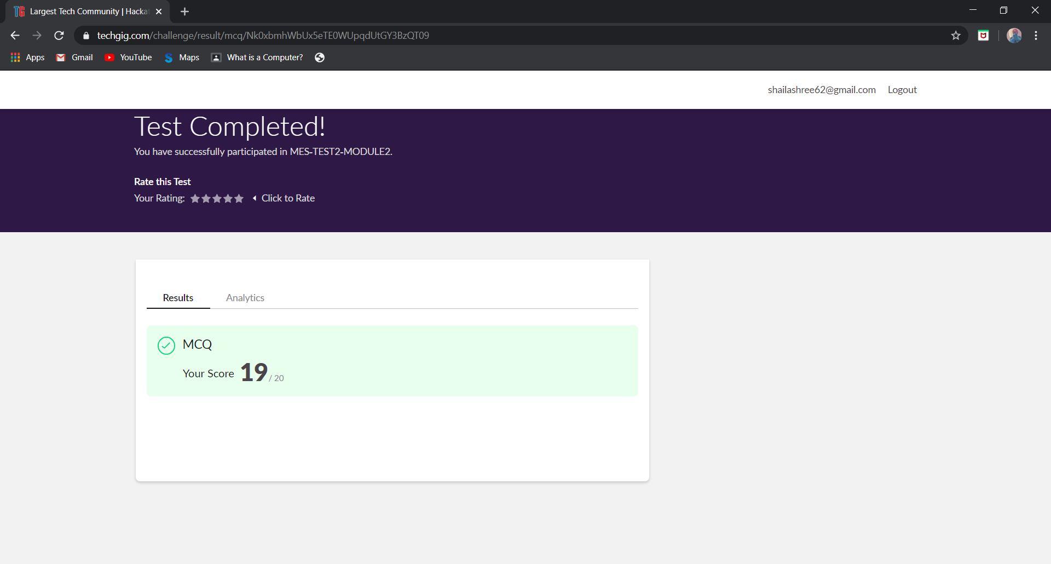

This is the completion of test and marks obtained for 18CS44.

Also 18KAK49 test was scheduled from 2:00pm to 2:50pm. The portion for the IA was 10chapters there were 50 questions and time assigned was 50 minutes the questions were mcq type.

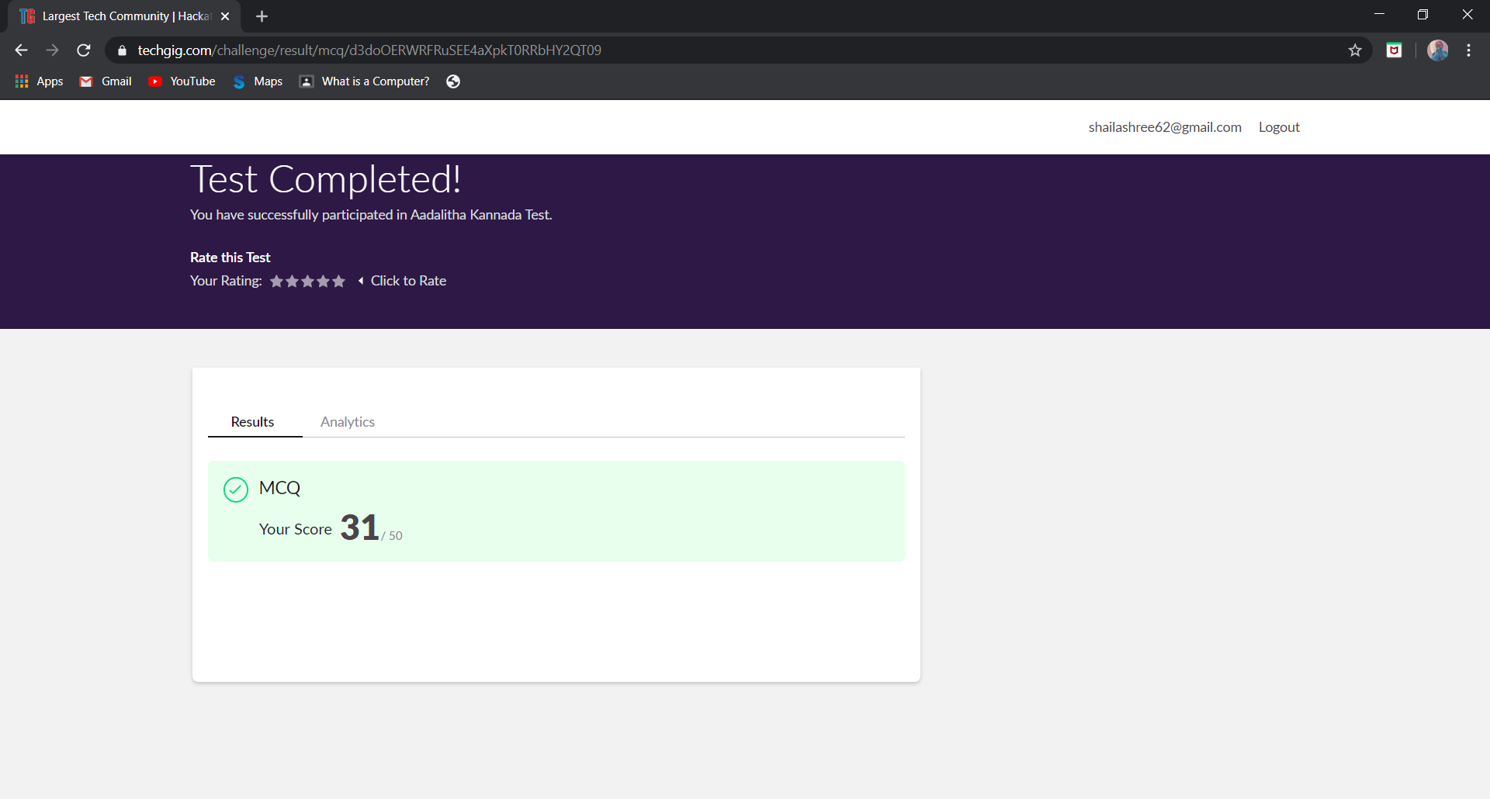

This is the completion of test and marks obtained for 18KAK49.

Online Certification Course Summary: Today I have learnt about series and data frames in Pandas and also accessing and modifying, combining data frames, functions, saving and loading data frames in Pandas.

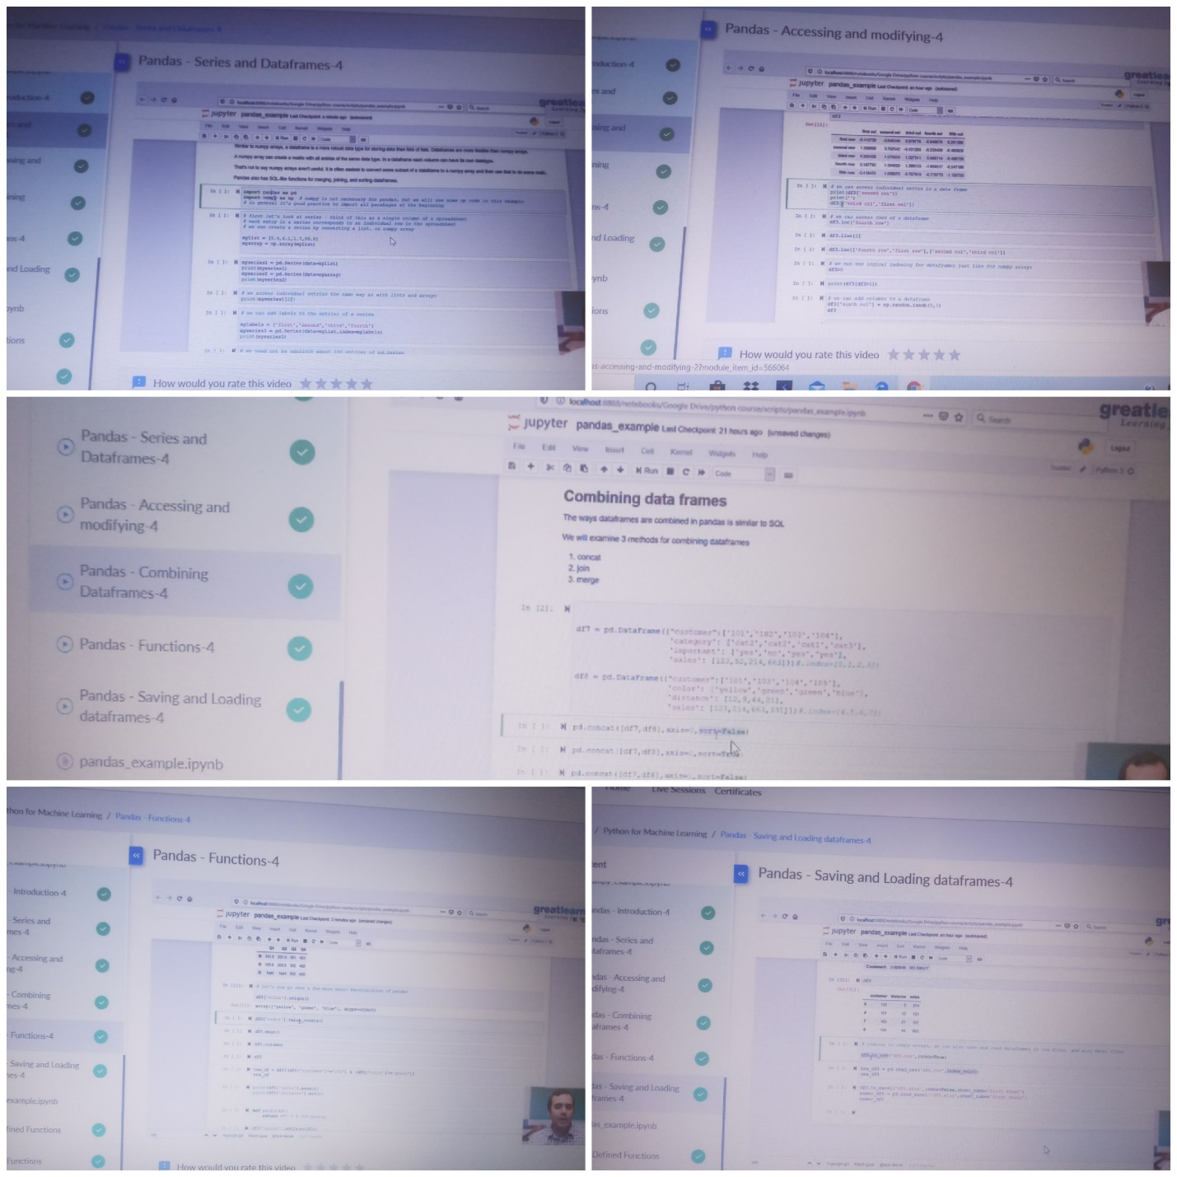

These are the snap shots of today’s sessions.

Online Coding Summary: **Today I had received one program from prof. Merlyn Mathias CSE Dept. The program is mentioned above in the coding challenges(pg.01). I have also uploaded it to my GitHub repository.**

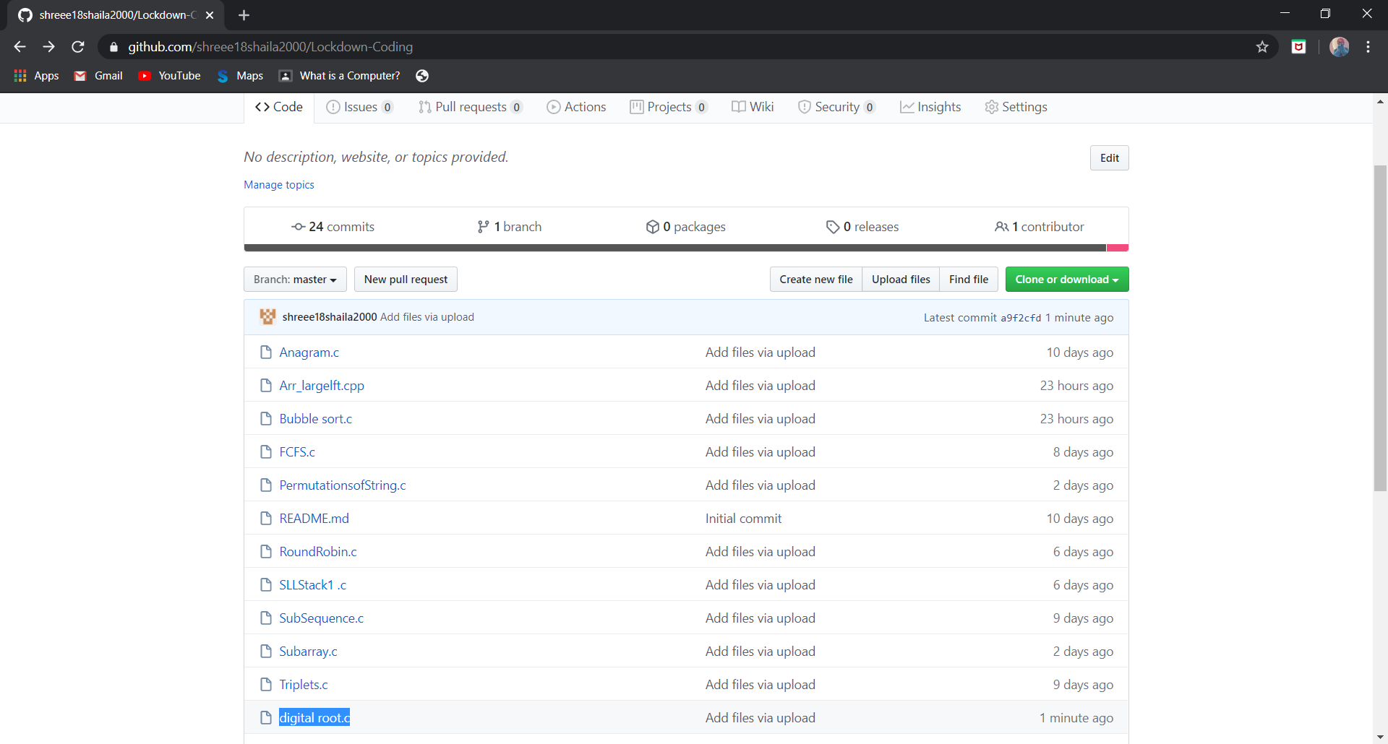

**This is the snap shot of my Github repository** were I have uploaded the code. File name is digital root.c